**AWS API Gateway**

Go to aws console and search api gateway

Create api

Select api (ex: rest api)

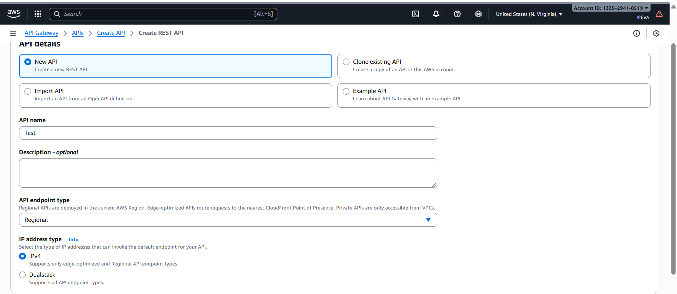

Create resource

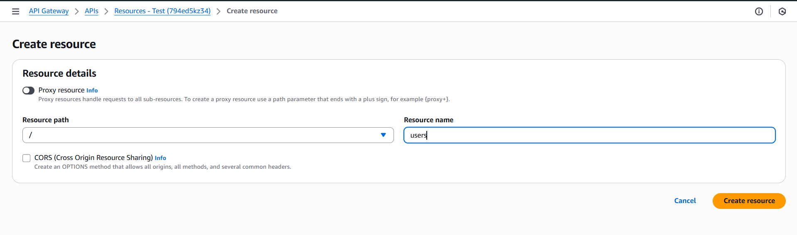

Create Get Method

Click on method

Select Get

Select Integration type (ex:lambda)

Add the lambda function

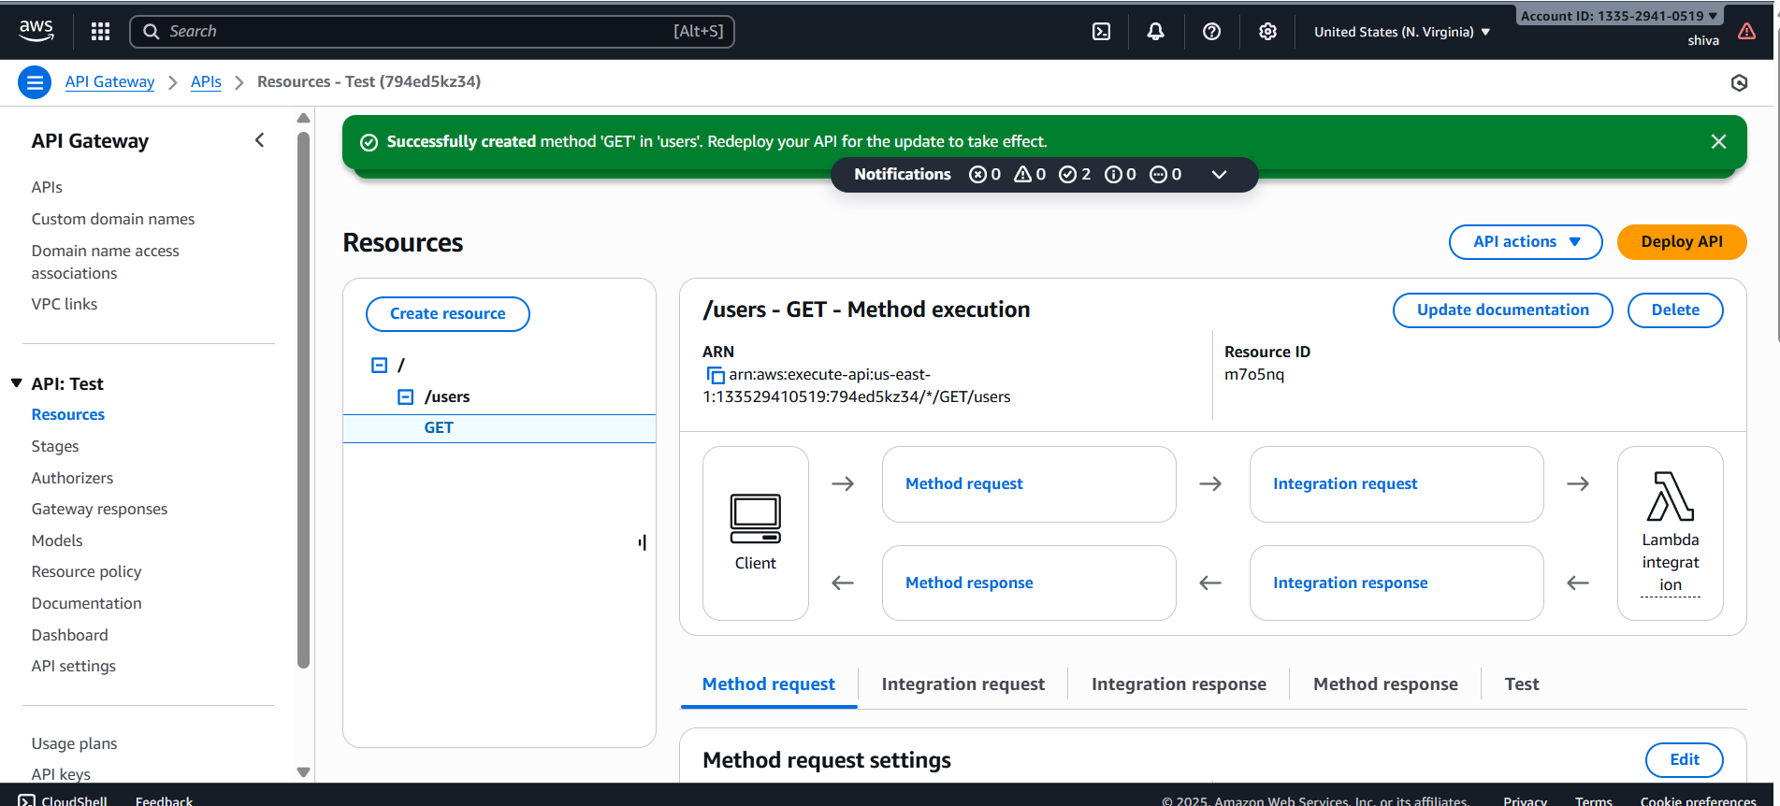

Create post request

Create Get Method

Click on method

Select Post

Select Integration type (ex:lambda)

Add the lambda function

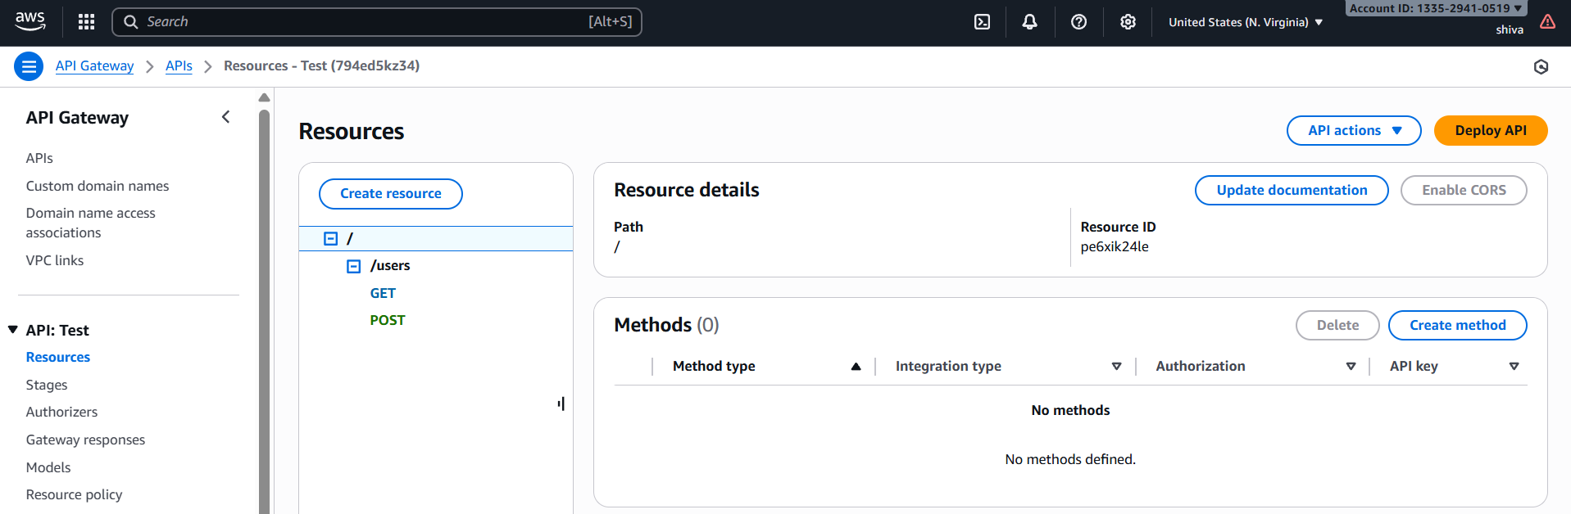

Select the root and click on deploy api

Add the stage (ex:dev

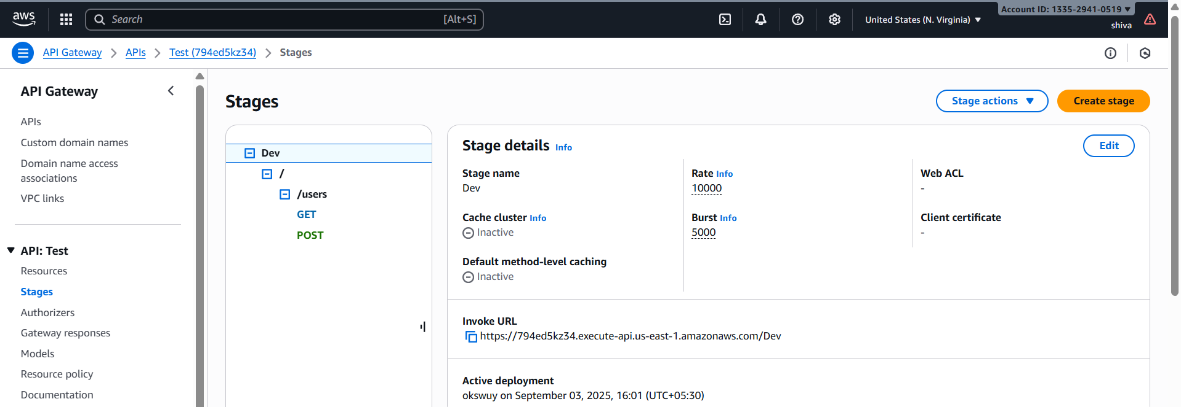

Copy the invoke url and test

